RHP 9 DSRIP Transforming Care Now
RHP 9 Story Telling Template

Our Audience:
Our target audiences are stakeholders, the general public, and other decision makers who are considering the wavier renewal process.
Our Purpose:
Our purpose is to provide the story of the impact that our RHP 9 Projects are making on the healthcare of the patients and clients we serve. We want to go beyond the numbers and statistics to tell the stories that show how what we are doing is making a difference in their lives. We want to be able to show the impact so that the general public, stakeholders, and other decision makers will see the value of the waiver and why it is important to continue supporting waiver activities.
Please submit a one page story associated with your project that should include the following elements:
Elements of the Story (One Pager):
- Title that grabs the attention of the reader: Identifies the issue and the name of Project
- Definition of the Issue being addressed
- Define the impact of the issue
- Highlight a recent success achieved and explain the impact
- Include pictures and graphics that tell the story (optional)
- Quotations from those who benefit from the project (Should be de-identified if we do not have a written consent form from them)
- Include logos from partner organizations
- Include your contact information.
Story Formatting Hints
- Avoid the use of acronyms in the titles.
- Avoid wordiness, passive language, grammatical, and spelling errors
- Use bullets whenever possible
- Avoid technical or health care jargon
RHP 9 DSRIP Transforming Care Now
Image Here | Story Title:  Quote from patient/client/provider*:  *be sure to get release for pictures/stories as appropriate
Issue Being Addressed:  Impact of Issue:  Logos Here | Highlight of Recent Success:  Any additional quotes/pictures/graphics:
Project Title/Unique ID#:
Contact Information:
RHP 9 DSRIP Transforming Care Now (Sample)
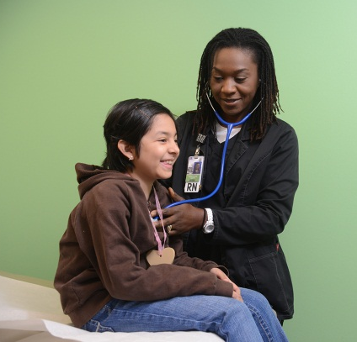  Image Here | Story Title:  Early Start on Late Night: Health Happens After Hours  Quote from patient/client  “Having that 8:00 p.m. appointment let me take my daughter, who was running a fever, to the doctor without using the emergency room. It turned out to be a minor issue, but allowed me to get her back to school faster and me not to miss work.”
Issue Being Addressed  Access to Care for non- emergent after hours healthcare needs.  Impact of Issue  Working parents, students, etc . . . cannot make it to the doctor’s office during “normal” business hours, results in costly and time consuming emergency room visits.  Logos Here | Highlight of Recent Success  Story of the patient’s trial for getting to treatment and what the outcome for them was that created a positive experience that they would not have had if they had to use the emergency room.  Any additional quotes/pictures/graphics/statistics . . .
Project Title/Unique ID#
Contact Information

